**The Secret Auction**

**$ Output of my program $**

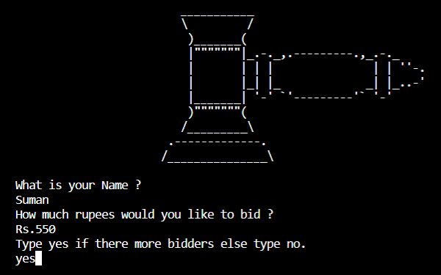

**By pressing enter after every yes or no the console clears so the next bidder cannot know the previous bid amount and SO the bid remains secret and auction is fair!!**

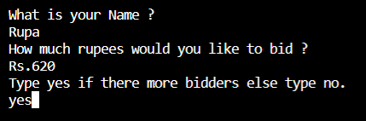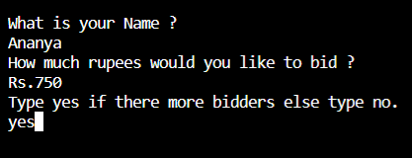

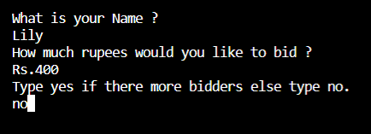

The final output is shown by pressing enter when there are no more bidders.

